EXPERIMENT 2

THE SCREW JACK EXPERIMENT

OBJECTIVE:
To examine the screw jack as an example of a simple machine and its law.
To study the screw jack as an example of theory of the thread.

APPARATUS:
1. The wall mounted screw jack
2. Pair of dividers
3. String
4. two-weight hangers
5. Loads
6. External calipers
7. Meter rule

DIAGRAM:

Cord

Load hook

Effort hook

Wheel

Trigger hook

Disc

Groove

Bolts and knots fixing screw jack to wall

PROCEDURE:
- A wall mounted jack with both the vee and square threads is used.
- Measured and record the pitch and the diameter of the disc.
- Record also the number of starts of the thread.
- Apply suitable loads of difference 2 1b and for each of the load apply similar smaller weights on the two hangers attached to the disc.
- Continuously apply the smaller weights until it reaches the limit such that its effort was greater than the corresponding load in order for it to be brought down.
- This procedure is done for both the vee and square thread.

RESULTS:

The vee thread

Load/Ib (W) | Load /N  (W) | Effort /Ib  (E) | Effort/N  Ea | MA= W/E | Eid = W/VR | Ew = Ea- Ei | ή = MA/VR
3.00 | 13.61 | 0.25 | 1.13 | 12.04 | 0.71 | 0.42 | 0.62
5.00 | 22.68 | 0.36 | 1.63 | 13.91 | 1.18 | 0.45 | 0.72
7.00 | 31.75 | 0.47 | 2.13 | 14.91 | 1.65 | 0.48 | 0.77
9.00 | 40.82 | 0.62 | 2.81 | 15.22 | 2.12 | 0.69 | 0.79
11.00 | 49.89 | 0.74 | 3.36 | 15.84 | 2.58 | 0.78 | 0.82

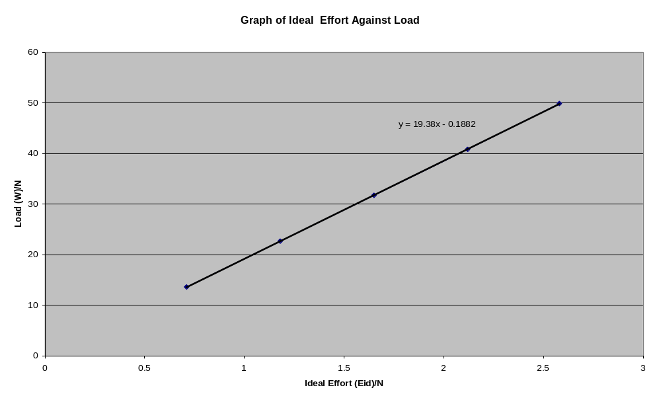

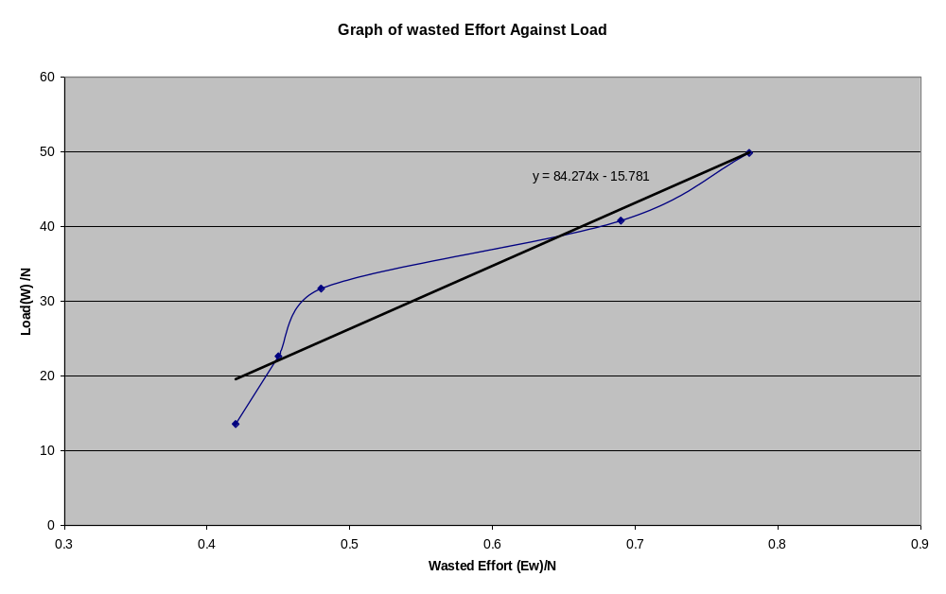
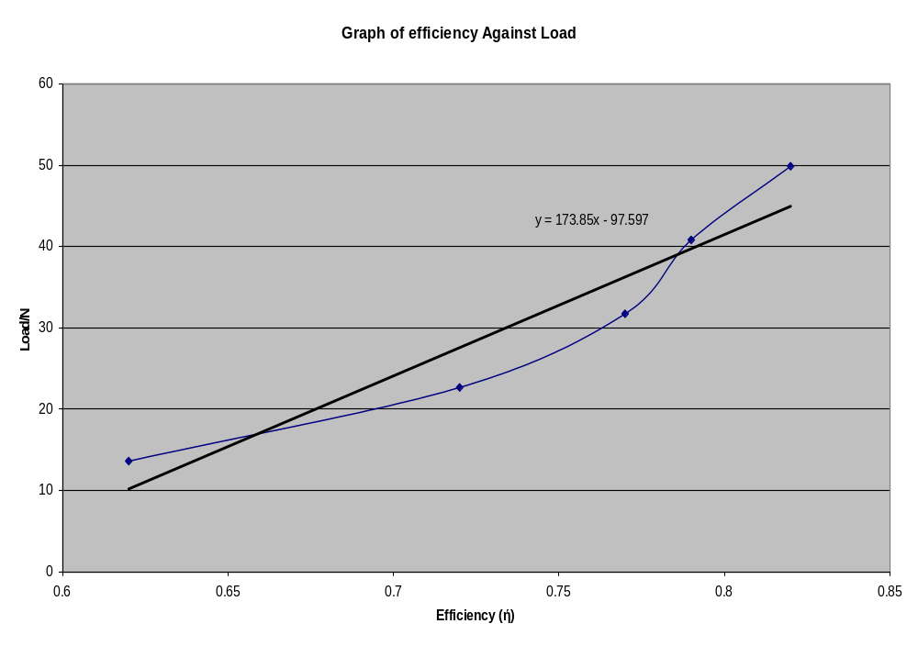

THE SQAURE THREAD

Load/Ib (W) | Load /N  (W) | Effort /Ib  (E) | Effort/N  Ea | MA= W/E | Eid = W/VR | Ew = Ea- Ei | ή = MA/VR
3.00 | 13.61 | 0.22 | 0.99 | 15.00 | 0.77 | 0.14 | 0.76
5.00 | 22.68 | 0.35 | 1.59 | 16.68 | 1.28 | 0.17 | 0.80
7.00 | 31.75 | 0.45 | 2.00 | 15.88 | 1.79 | 0.20 | 0.89
9.00 | 40.82 | 0.55 | 2.49 | 16.39 | 2.30 | 0.25 | 0.92
11.00 | 49.89 | 0.65 | 2.72 | 16.91 | 2.81 | 0.30 | 0.95

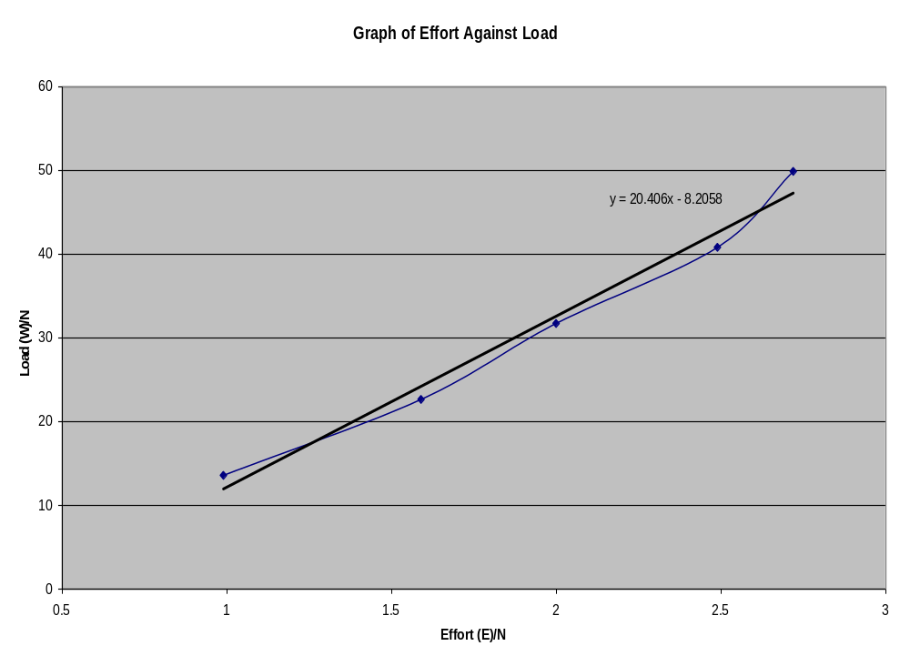

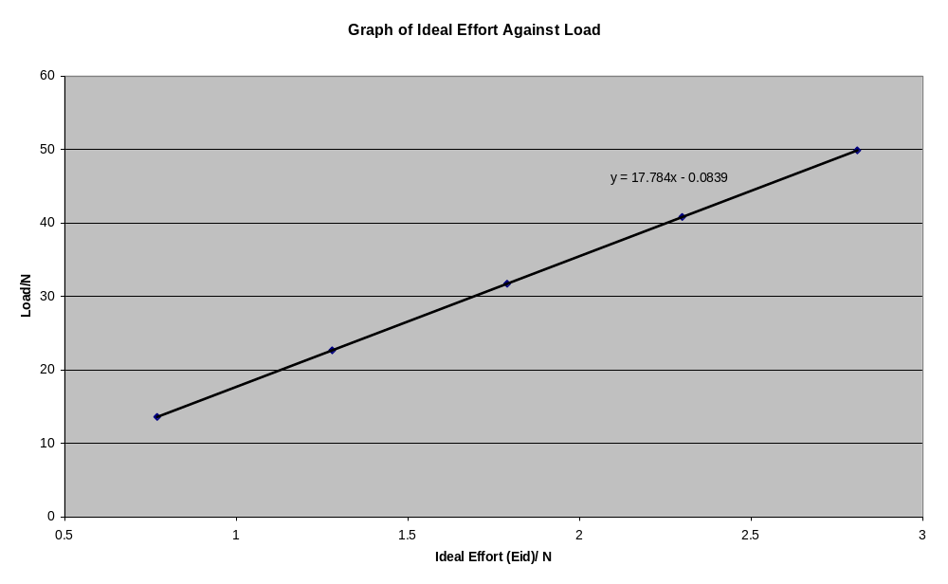

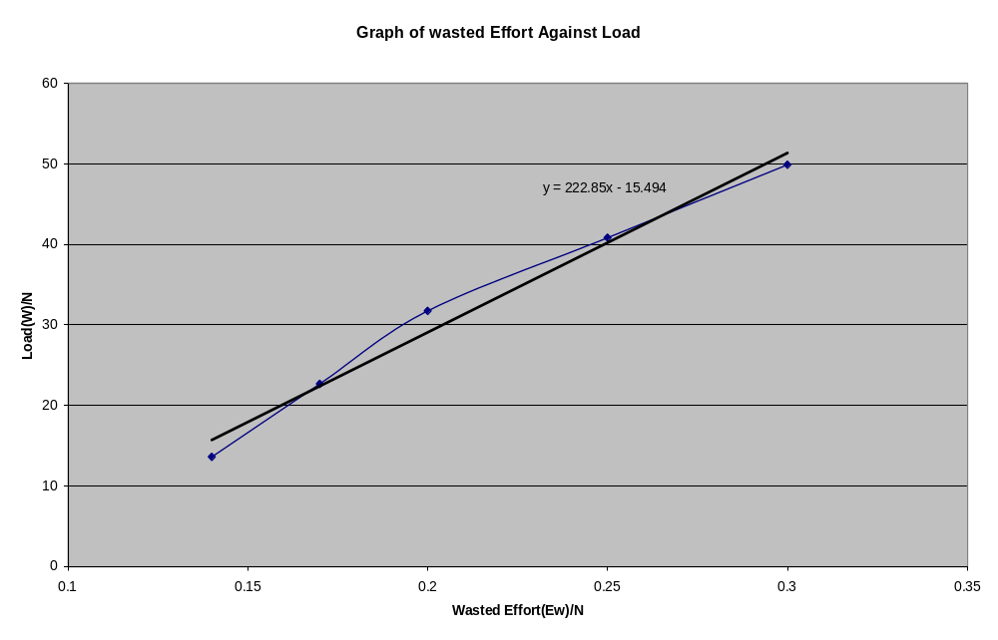

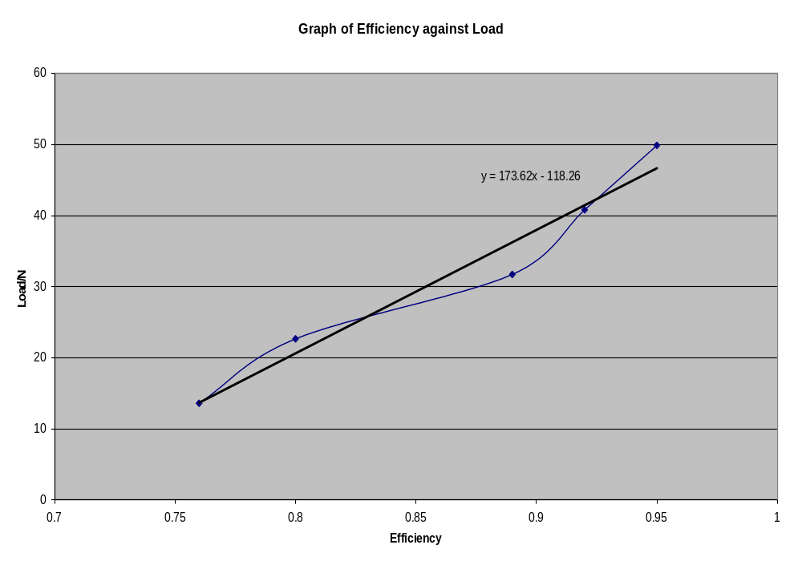
THEORY:
The velocity ratio may be calculated as follows:
For one turn of the screw it advances a distance called the lead. This may be equal one, two or more pitches. The pitch is the axial distance between corresponding points on adjacent threads. The effort E is applied at the rim of a disc, fixed to thread. The effective radius of this disc (including allowance for the cord) is R_{D}; then the distance moved by the effort for one turn of the thread is

Velocity Ratio = 2πR_{D} ……… (1)
L

Figure 1
R
F
W
W
P
L
ΠD
The relationship between these forces can be determine in several ways by resolving forces vertically and horizontally, by resolving forces parallel and perpendicular to the plane or by drawing the force vector triangle.

Figure 2
R
N
F
W
P
From figure 2 it is clear that;

P = W tan (θ + γ)…………….. (3)

Now P, acts on diameter D while E acts at the radius R_{D}

Therefore, E = D ……………… (4)
P 2R_{D}

Therefore, W = E θ 2R_{D θ =} 2R_{D……………………………..} (5)
E P θ D D tan (θ + γ)

Multiplying the numerator and the denominator by π therefore

W = 2πR_{D} …………………. (6)
E πD tan (θ + γ)

From (2) tan θ = L
πD

Therefore W = 2πR_{D} θ = tan θ ………… (7)
E L tan (θ+ γ)
CALCULATIONS

Vee thread

Let Rd be the radius of the disc = 0.01075m
D be the diameter of the thread = 0.0215m
Pitch, L = 0.0035

Velocity Ratio (V.R) = 2πR_{D}
L
= 2(π×0.01075)/0.0035

= 19.301

Square thread
Let Rd be the radius of the disc = 0.01075m
D be the diameter of the thread = 0.0215m
Pitch, L = 0.0038

Velocity Ratio (V.R) = 2πR_{D}
L
= 2(π×0.01075)/0.0038

= 17.78

PRECAUTION:

- It was ensured that there was no rotational motion of the thread when it was left to descend. Hence steady motion was ensured throughout the experiment.

CONCLUSION

Friction occurred between the thread and the disc which also brought about slight errors. Screw jacks are used to unscrew tyres of vehicles.

